**Configuration – Account Management (Account Close)**  
Bug Report

Afrida Rahman

Last Executed: 03/09/2024

**Casa Account Close (saving account)**

1. The system doesn't allow closing a saving account, as the balance is 0. It's a saving account, 5023423163201.

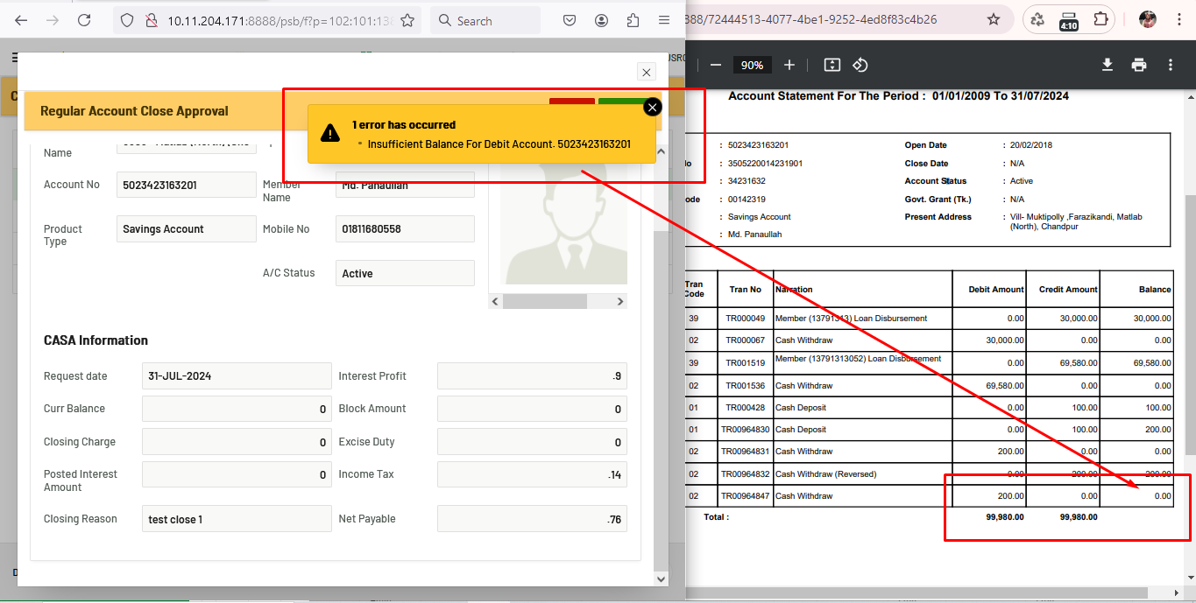

1. Can't close this account. the system showing the duplicate issue. a/c: 5023434206701, old a/c: 3505220014231901, 100265 - a/c no. It's on 3505 branch and test server.

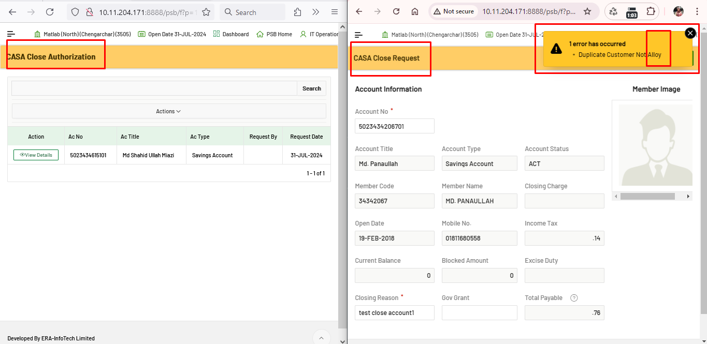

1. Database it's showing current balance of 100, but in the report the balance shows 0.

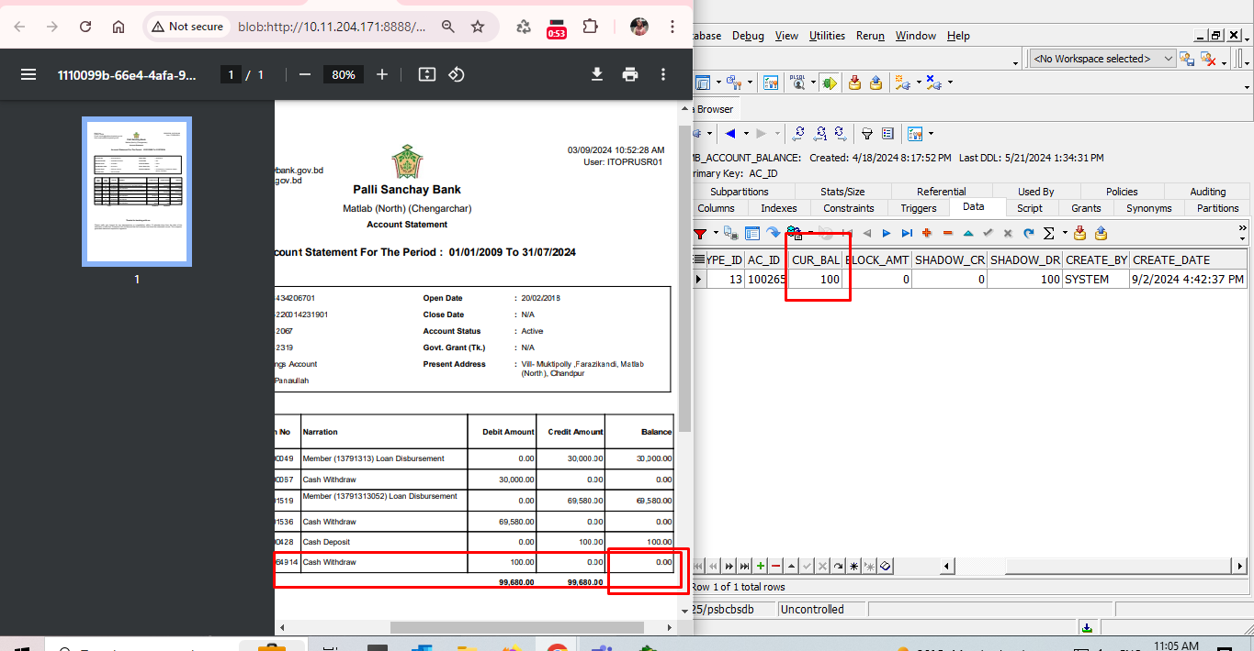

1. unable to download the pdf report of "A/C Statement" Report module

